ACROPOLIS INSTITUTE OF TECHNOLOGY AND RESEARCH

Department of IT Synopsis
On

SynapseOS: An AI-Driven Intelligent Operating System

- Introduction

Overview
The evolution of Artificial Intelligence (AI) has transformed computing, paving the way for operating systems that are not only functional but also intelligent and adaptive. Traditional operating systems primarily rely on predefined instructions and manual user interaction, offering limited adaptability.
SynapseOS is a lightweight, AI-embedded operating system designed to provide a seamless and intelligent computing experience. It incorporates modules such as a voice-enabled assistant, smart file organization, predictive task and resource management, and user behavior learning. This integration of AI at the OS level transforms everyday computing into an adaptive, context- aware, and efficient process.
SynapseOS aims to revolutionize personal computing, embedded systems, and smart devices by providing proactive system management, natural language interaction, and personalized experiences without compromising performance or resource efficiency.

Purpose
- Intelligent User Interaction: Provide a voice and NLP-powered interface for executing commands and managing system operations.

- Smart Resource Management: Predict and allocate resources based on user behavior and system requirements.

- Automated File Organization: Categorize and manage files intelligently using AI-driven algorithms.

- Proactive System Control: Enable the OS to take preventive and predictive actions to optimize performance and security.

- AI-Integrated OS Learning: Continuously adapt to the user’s habits, preferences, and workflows for a more personalized computing environment.

Literature Survey

Existing Problem

Sr. No. | Name of Solution | Features | Limitations
1. | Windows 11 with Cortana | Voice assistant, smart search | Heavy system resources, privacy concerns
2. | macOS with Siri  + Spotlight | Natural language commands, intelligent file search | Hardware dependency, restricted customization
3. | Ubuntu Linux with Mycroft AI | customizable AI modules, cross-platform | Limited app support, slower AI development

  - Proposed Solution
SynapseOS introduces AI-powered features directly into the core operating system. By combining low-level OS development with advanced AI models, it offers real-time, intelligent, and context-aware system management.

Key Features:

- Voice-Enabled Smart Shell: Accepts natural language commands and executes them at OS level.
- AI-Driven File Organization: Automatically categorizes and sorts files based on type, usage, and priority.
- Predictive Resource Allocation: Anticipates high-demand tasks and optimizes CPU, memory, and storage allocation accordingly.
- Voice-Based Authentication: Provides secure, biometric voice login.
- User Behavior Learning: Adjusts system configurations and recommendations based on user patterns.
- Lightweight & Modular: Designed for performance efficiency in both personal and embedded devices.

Theoretical Analysis

Diagrams

    - Block Diagram

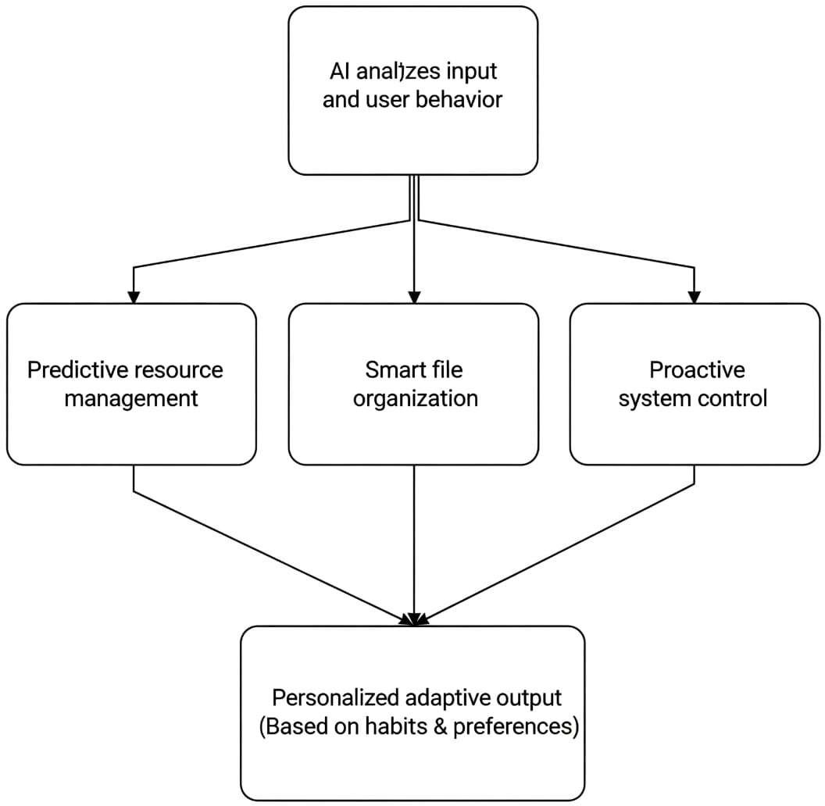

Fig.3.1.1. Block Diagram

Hardware/Software Designing
    - Hardware Requirements
      - Processor: x86/x86_64 architecture, minimum dual-core CPU (quad-core recommended)
      - RAM: Minimum 2 GB (4 GB recommended)
      - Storage: Minimum 10 GB (SSD recommended)
      - Microphone: For voice input
      - Speaker / Audio Output: For voice assistant responses
      - Display: Standard monitor or embedded system display

Software Requirements

Core OS Development Stack:

      - Languages: C, Assembly (kernel), Python (AI modules)
      - Bootloader: GRUB
      - Compiler/Assembler: GCC (cross-compiler), NASM
      - Emulator/Testing: QEMU, Bochs
      - Build Tools: Makefile, Bash scripting

AI & Voice Processing Stack:

      - AI Frameworks: PyTorch / TensorFlow
      - Speech Recognition: Vosk / DeepSpeech
      - NLP Models: Transformers-based language models
      - File Organization AI: Custom-trained classification models

File System Support: FAT12 / FAT32 or custom lightweight file system

Applications
- Education & Research – For OS learning, AI-in-OS experiments, student projects.
- Embedded Systems & IoT – Runs on smart/industrial devices with AI health monitoring.
- Cybersecurity – AI-powered anomaly detection, rescue OS, forensic tools.
- IT & System Administration – Diagnostic OS, predictive maintenance, monitoring tool.
- Edge & Cloud Computing – Lightweight OS for edge servers, VM monitoring, load prediction.
- Personal Computing – Minimal AI-driven OS for old PCs, customizable UI, assistant features.

REFERENCES
- A. Silberschatz, P. B. Galvin, and G. Gagne, “Operating System Concepts,” Wiley, 10th Edition, 2018.
- J. Molloy, “Kernel Development Series,” [Online]. Available: http://www.jamesmolloy.co.uk
- OSDev.org, “OS Development Wiki and Tutorials,” [Online]. Available: https://wiki.osdev.org
- PyTorch Documentation, [Online]. Available: https://pytorch.org/docs/
- TensorFlow Documentation, [Online]. Available: https://www.tensorflow.org/
- Vosk Speech Recognition Toolkit, [Online]. Available: https://alphacephei.com/vosk

Guided By: Group Members:
Prof. Monika Choudhary Atharv Sharma (0827IT233D02)
Khushi Agrawal (0827IT221076)
Abhishek Rathore (0827IT233D01)
Jatin Rao (0827IT233D03)

